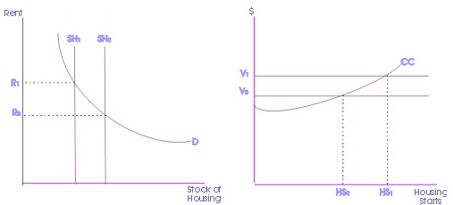
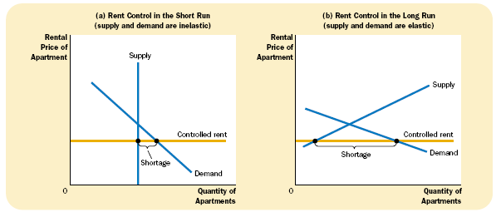
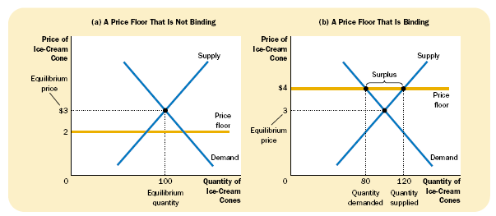
Inferring housing prices can be reduced to the problem of finding the equilibrium between housing supply and housing demand. This is not a straightforward task, as housing demand and housing supply are not observed empirically through an index exactly. Instead, we aim to investigate some proxies for housing demand and housing supply:

Housing Demand
- Housing Market Index (HMI)
  - National Association of home builders
  - http://www.nahb.org/page.aspx/category/sectionID=134
  - Survey of 300 largest homebuilder activity
- Other Economic Indicators
  - http://www.realtor.org/research/research/ecoindicator
  - CPI
  - Unemployment
  - CPI
  - Fixed Rate Mortgage Rate
  - GDP
  - Consumer Confidence
  - Retail Sales
Housing Supply
Housing supply is defined as the existing housing stock plus housing starts less depreciation.
- NAHB Housing Starts Data
- NAHB Remodeling Market Index (RMI)
- Housing Starts/Completions by Purpose/Design – Census Bureau
- PPI
- New/Existing/Pending Home Sales

Total list of economic indicators
http://www.census.gov/epcd/econ/www/indijun.htm

